Timeline

|  |
| --- |
| Marker with solid fillMarker with solid fillMarker with solid fillMarker with solid fillMarker with solid fillMarker with solid fill  **???**  **2022**  **2020**  **2013**  **2007**  **2002** |

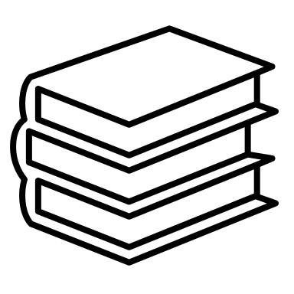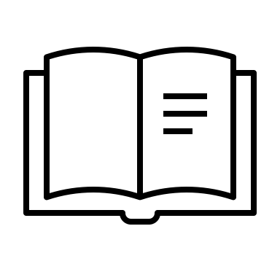Education

|  |
| --- |
| Books on shelf with solid fillOpen book with solid fillBooks with solid fillDesk with solid fill |

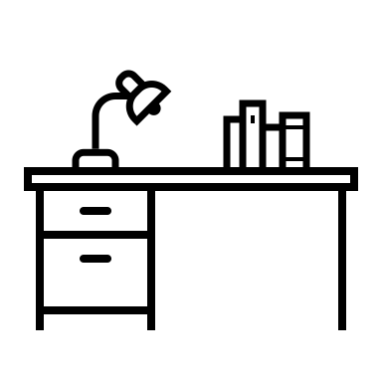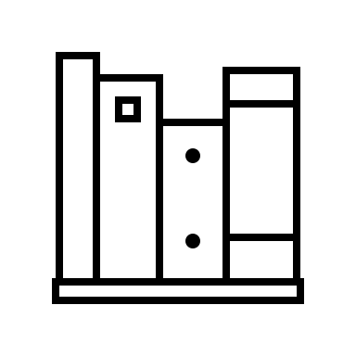

Music

|  |
| --- |
| Music note with solid fillMusic notes with solid fill |

Projects

|  |
| --- |
| Bar graph with upward trend with solid fillList with solid fillBlog with solid fillBar chart with solid fill3d Glasses outlineAtom with solid fill |

Contact me

|  |
| --- |
| Employee badge with solid fillAddress Book with solid fill |

About me

|  |
| --- |
| Head with gears with solid fillMale profile with solid fillPerson with idea with solid fill |

Room

|  |
| --- |
| Internet Of Things with solid fillRobot with solid fillConvertible with solid fillTennis racket and ball with solid fillProcessor with solid fill |

Study

|  |
| --- |
| Qr Code with solid fillProgrammer male with solid fillMorse Code with solid fill |